GUEST SPEAKER GABE LANDES
1 John 4:7-16
WAVE CHURCH SD | MAY 26, 2019

1 John 4:7-16 (NIV) ⁷ Dear friends, let us love one another, for love comes from God. Everyone who loves has been born of God and knows God. ⁸ Whoever does not love does not know God, because God is love. ⁹ This is how God showed his love among us: He sent his one and only Son into the world that we might live through him. ¹⁰ This is love: not that we loved God, but that he loved us and sent his Son as an atoning sacrifice for our sins. ¹¹ Dear friends, since God so loved us, we also ought to love one another. ¹² No one has ever seen God; but if we love one another, God lives in us and his love is made complete in us.
¹³ This is how we know that we live in him and he in us: He has given us of his Spirit. ¹⁴ And we have seen and testify that the Father has sent his Son to be the Savior of the world. ¹⁵ If anyone acknowledges that Jesus is the Son of God, God lives in them and they in God. ¹⁶ And so we know and rely on the love God has for us. God is love. Whoever lives in love lives in God, and God in them.

NOTES.

________________________________________________________
________________________________________________________
________________________________________________________
________________________________________________________
________________________________________________________
________________________________________________________
________________________________________________________
________________________________________________________
________________________________________________________
________________________________________________________
________________________________________________________
________________________________________________________
________________________________________________________
________________________________________________________
________________________________________________________
________________________________________________________
________________________________________________________
________________________________________________________
________________________________________________________
________________________________________________________

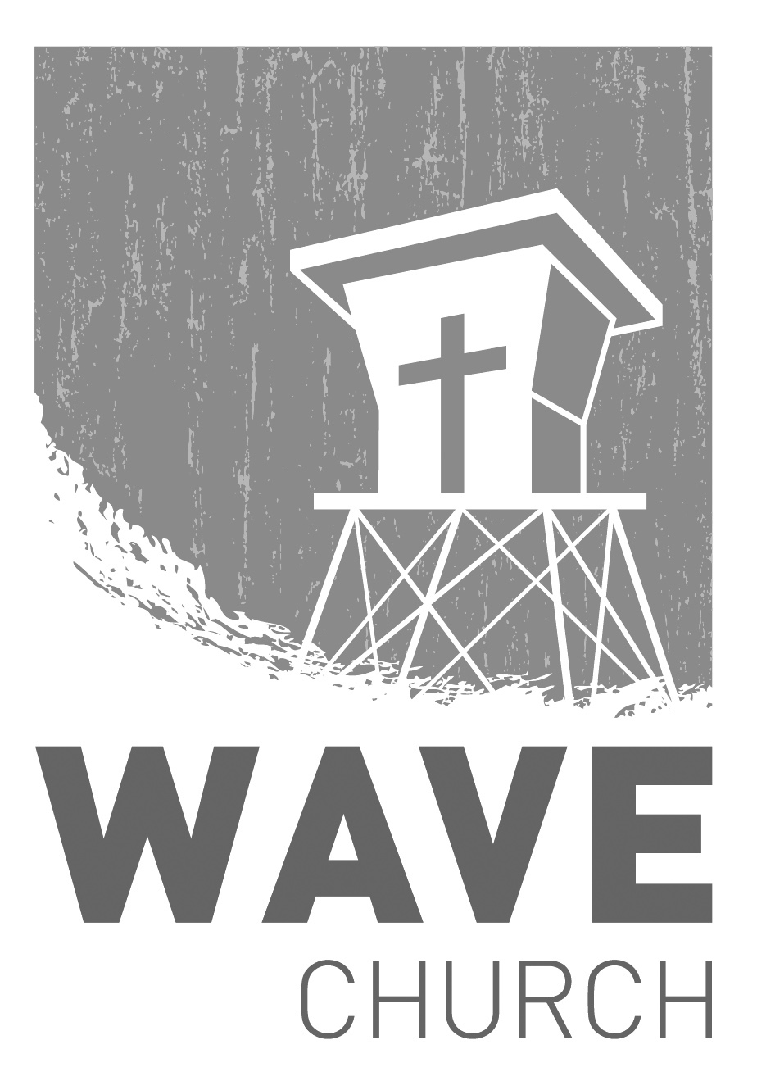
CONNECT.
Connect | Grow | Serve

Sundays at 10 a.m.
Willow Grove Elementary
14727 Via Azul
San Diego, CA | 92127
858-859-2831
Wavechurchsd.com
Wave Church

Welcome to

.
STARTING POINT | June 2nd
Our next Starting Point lunch is on June 2nd, right after church! If you would like to learn more about Wave, meet our pastors, staff, and other newcomers, then join us for a family meal, and hear about the story and heart of our church. Fill out a connection card, email us at info@wavechurchsd.com, or just show up!
GROW.
.
LIFE GROUP STUDY GUIDE | wavechurchsd.com/study/
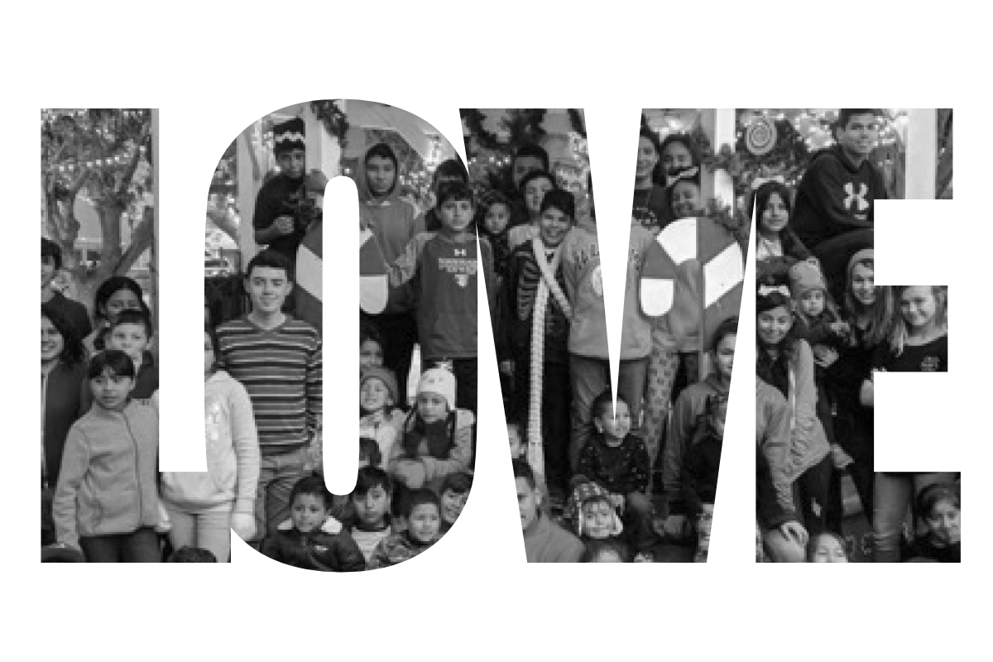
Our Life Group Study Guides are available online! If you’re part of a Life Group, these questions will help prepare you for the discussion, or please use them in your personal time to reflect on God’s word and dive deeper into the message.
http://wavechurchsd.com/study/

JR. HIGH SUMMER CAMP | June 30th – July 5th
There are a few spots left for our middle schoolers this summer! If you have a student going into 6th grade, or just coming out of 8th, and they are looking for
a Christ-centered, fun-filled summer camp, please contact Steven Perez at steven@weavechurchsd.com if you want more information or need to sign up!
SERVE.
.
WAVE FAMILY CAMP | Aug. 8-10, 2019
We will be traveling to La Misión, Mexico for a two-night, three-day family missions trip at Door of Faith Orphanage. During our time there, we will be spending time with the kids, serving meals, and helping prepare a space for Door of Faith's new school! Making quality connections is what missions are all about, so please bring your whole family! For more information, and to register, check the Newsletter or visit our website. Hope to see you there!
WE NEED YOUR HELP | Serve Teams
We have a few service teams who are looking for more volunteers. Are you part of a serve team yet? Or would you like to try something new? Serving is a great way to make new connections, while making a difference in our church body. Please fill out a connection card with your name and the area you would be willing to serve, and a team leader will be in touch with you!

- Hospitality: Greeters
- Audio/Visual: Slides
- Kids Ministry: Classroom volunteers

