PARABLE OF THE DISHONEST MANAGER
Luke 16:1-16
WAVE CHURCH SD | MAY 19, 2019

WHAT YOU INVEST YOUR LIFE IN HAS ETERNAL IMPACT

Matthew 19:23-24 (NIV) ²³ Then Jesus said to his disciples, “Truly I tell you, it is hard for someone who is rich to enter the kingdom of heaven. ²⁴ Again I tell you, it is easier for a camel to go through the eye of a needle than for someone who is rich to enter the kingdom of God.”

1 Timothy 6:10 (ESV) ¹⁰ For the love of money is a root of all kinds of evils. It is through this craving that some have wandered away from the faith and pierced themselves with many pangs.

WEALTH IS A BLESSING AND STEWARDSHIP FROM GOD

Psalm 24:1 (NIV), Deuteronomy 8:18 (NIV)

Luke 16:1-9 (ESV) He also said to the disciples, “There was a rich man who
had a manager, and charges were brought to him that this man was wasting his possessions. ² And he called him and said to him, ‘What is this that I hear about you? Turn in the account of your management, for you can no longer be manager. ³ And the manager said to himself, ‘What shall I do, since my master is taking the management away from me? I am not strong enough to dig, and I am ashamed to beg. ⁴ I have decided what to do, so that when I am removed from management, people may receive me into their houses.’ ⁵ So, summoning his master’s debtors one by one, he said to the first, ‘How much do you owe my master?’ ⁶ He said, ‘A hundred measures of oil.’ He said to him, ‘Take your bill, and sit down quickly and write fifty.’ ⁷ Then he said to another, ‘And how much do you owe?’ He said, ‘A hundred measures of wheat.’ He said to him, ‘Take your bill, and write eighty.’ ⁸ The master commended the dishonest manager for his shrewdness. For the sons of this world are more shrewd in dealing with their own generation than the sons of light. ⁹ And I tell you, make friends for yourselves by means of unrighteous wealth, so that when it fails they may receive you into the eternal dwellings.

THE DISHONEST MANAGER IS A DISHONEST MANAGER

- WE ARE OWNERS OF NOTHING, MANAGERS OF EVERYTHING!

THE RICH MAN IS A RICH MAN

SHREWDNESS | PHRONIMOS
to act with foresight, forward thinking, intentionality tricky, cunning.

SONS OF THIS WORLD = SINNERS

SONS OF LIGHT = SAINTS

- THE END OF YOUR LIFE IS A MYTH; WE MUST PLAN FOR BEYOND DEATH.

Matt. 6:19-21, Rom. 14:12, 2 Cor. 5:10, 1 Cor. 3:11-15

- USE WHAT YOU HAVE TO INVEST IN PEOPLE. IN ETERNITY, THE ONLY INVESTMENTS THAT COUNT ARE PEOPLE.

Luke 16:10-13 (ESV) ¹⁰ “One who is faithful in a very little is also faithful in much, and one who is dishonest in a very little is also dishonest in much. ¹¹ If then you have not been faithful in the unrighteous wealth, who will entrust to you the true riches? ¹² And if you have not been faithful in that which is another’s, who will give you that which is your own? ¹³ No servant can serve two masters, for either he will hate the one and love the other, or he will be devoted to the one and despise the other. You cannot serve God and money.”

- FAITHFULNESS IS NOT MEASURED BY THIS WORLD’S STANDARDS.

- TRULY FAITHFUL PEOPLE ARE GENEROUS BECAUSE OF THEIR CHARACTER NOT BECAUSE OF THEIR CIRCUMSTANCES.

- THIS LIFE IS SIMPLY A RÉSUMÉ FOR THE NEXT.
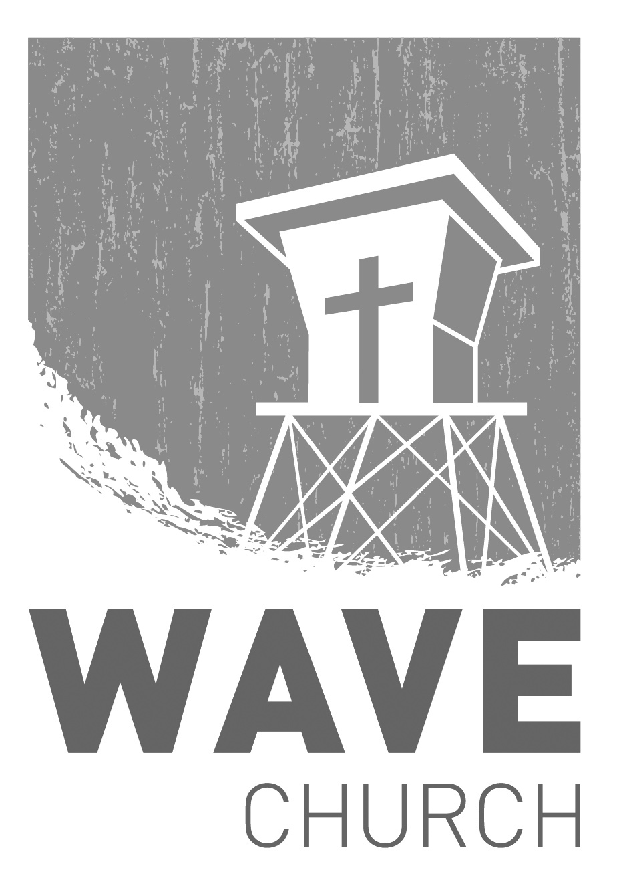
CONNECT.
Connect | Grow | Serve

Sundays at 10 a.m.
Willow Grove Elementary
14727 Via Azul
San Diego, CA | 92127
858-859-2831
Wavechurchsd.com
Wave Church

Welcome to

.
WAVE WEEKLY NEWSLETTER
Want to keep up with all that is going on at Wave? Simply fill out your communication card and write ‘Newsletter’ to get a weekly email update
from Wave!
GROW.
.
LIFE GROUP STUDY GUIDE | wavechurchsd.com/study/
Our Life Group Study Guides are available online! The study guide will help you unpack what you heard on Sunday, while diving deeper into God's word during your group discussions, or as a time of personal reflection.
http://wavechurchsd.com/study/

SERMON PODCASTS | wavechurchsd.com/sermons/
Have you missed a few sermons recently? If you have been waylaid by viruses, or are traveling and can’t make it to church, don’t despair -- our sermons are available online! Want to hear a section again, or send it to a friend? Download our sermon podcasts at http://wavechurchsd.com/sermons/
SERVE.
.
WAVE FAMILY CAMP | Aug. 8-10, 2019
We will be traveling to La Misión, Mexico for a two-night, three-day family missions trip at Door of Faith Orphanage. During our time there, we will be spending time with the kids, serving meals, and helping prepare a space for Door of Faith's new school! Making quality connections is what missions are all about, so please bring your whole family! For more information, and to register, check the Newsletter or visit our website. Hope to see you there!
WE NEED YOUR HELP | Serve Teams
We have a few service teams who are looking for more volunteers. Are you part of a serve team yet? Or would you like to try something new? Serving is a great way to make new connections, while making a difference in our church body. Please fill out a connection card with your name and the area you would be willing to serve, and a team leader will be in touch with you!

- Hospitality: Greeters
- Audio/Visual: Slides
- Kids Ministry: Classroom volunteers

