PARABLE OF THE WORKERS IN THE VINEYARD
MATTHEW 20:1-19
WAVE CHURCH SD | MARCH 31, 2019

John 6:66-71 (ESV) ⁶⁶ After this many of his disciples turned back and no longer walked with him. ⁶⁷ So Jesus said to the twelve, “Do you want to go away as well?” ⁶⁸ Simon Peter answered him, “Lord, to whom shall we go? You have the words of eternal life, ⁶⁹ and we have believed, and have come to know, that you are the Holy One of God.” ⁷⁰ Jesus answered them, “Did I not choose you, the twelve? And yet one of you is a devil.” ⁷¹ He spoke of Judas the son of Simon Iscariot, for he, one of the twelve, was going to betray him.

Luke 23:42-43 (ESV) ⁴² And he said, “Jesus, remember me when you come into your kingdom.” ⁴³ And he said to him, “Truly, I say to you, today you will be with me in paradise.”

Exodus 33:19 (ESV) ¹⁹ And he said, “I will make all my goodness pass before you and will proclaim before you my name ‘The Lord.’ And I will be gracious to whom I will be gracious, and will show mercy on whom I will show mercy.

Matthew 20:1-16 (ESV) “For the kingdom of heaven is like a master of a
house who went out early in the morning to hire laborers for his vineyard.
² After agreeing with the laborers for a denarius a day, he sent them into his vineyard. ³ And going out about the third hour he saw others standing idle in the marketplace, ⁴ and to them he said, ‘You go into the vineyard too, and whatever
is right I will give you.’ ⁵ So they went. Going out again about the sixth hour and the ninth hour, he did the same. ⁶ And about the eleventh hour he went out and found others standing. And he said to them, ‘Why do you stand here idle all day?’ ⁷ They said to him, ‘Because no one has hired us.’ He said to them, ‘You go into the vineyard too.’ ⁸ And when evening came, the owner of the vineyard said to his foreman, ‘Call the laborers and pay them their wages, beginning with the last, up to the first.’ ⁹ And when those hired about the eleventh hour came, each of them received a denarius. ¹⁰ Now when those hired first came, they thought they would receive more, but each of them also received a denarius. ¹¹ And on receiving it they grumbled at the master of the house, ¹² saying, ‘These last worked only one hour, and you have made them equal to us who have borne the burden of the day and the scorching heat.’ ¹³ But he replied to one of them, ‘Friend, I am doing you no wrong. Did you not agree with me for a denarius? ¹⁴ Take what belongs to you and go. I choose to give to this last worker as I give to you. ¹⁵ Am I not allowed to do what I choose with what belongs to me? Or do you begrudge my generosity?’ ¹⁶ So the last will be first, and the first last.”

Luke 13:29-30 (ESV) ²⁹ And people will come from east and west, and from north and south, and recline at table in the kingdom of God. ³⁰ And behold, some are last who will be first, and some are first who will be last.”
WHAT DO WE LEARN ABOUT THE KINGDOM OF HEAVEN?

- THE KINGDOM OF HEAVEN IS NOT A REWARD FOR PEOPLE WHO DESERVE IT.
Ephesians 1:7-14 (NIV)

- THE KINGDOM OF HEAVEN WILL CAUSE US TO SAY, “WAIT, WHAT?!”

WHAT DO WE LEARN ABOUT JESUS?

- JESUS IS A GRACIOUS MASTER WORTHY OF CELEBRATION IN EVERY WAY.

- JESUS MAKES THE RULES. HE ALWAYS KEEPS HIS PROMISE. HE GIVES US MORE THAN WE DESERVE.

WHAT DO WE LEARN ABOUT THE LABORERS?

- ALL ARE EQUALLY UNDERSERVING OF GOD’S GRACE.

- THE JOY OF GRACE IS LOST WHEN WE DECIDE WE GET TO MAKE THE RULES.

MATTHEW 20:17-19 (ESV) ¹⁷ And as Jesus was going up to Jerusalem, he took the twelve disciples aside, and on the way he said to them, ¹⁸ “See, we are going up to Jerusalem. And the Son of Man will be delivered over to the chief priests and scribes, and they will condemn him to death ¹⁹ and deliver him over to the Gentiles to be mocked and flogged and crucified, and he will be raised on the third day.”
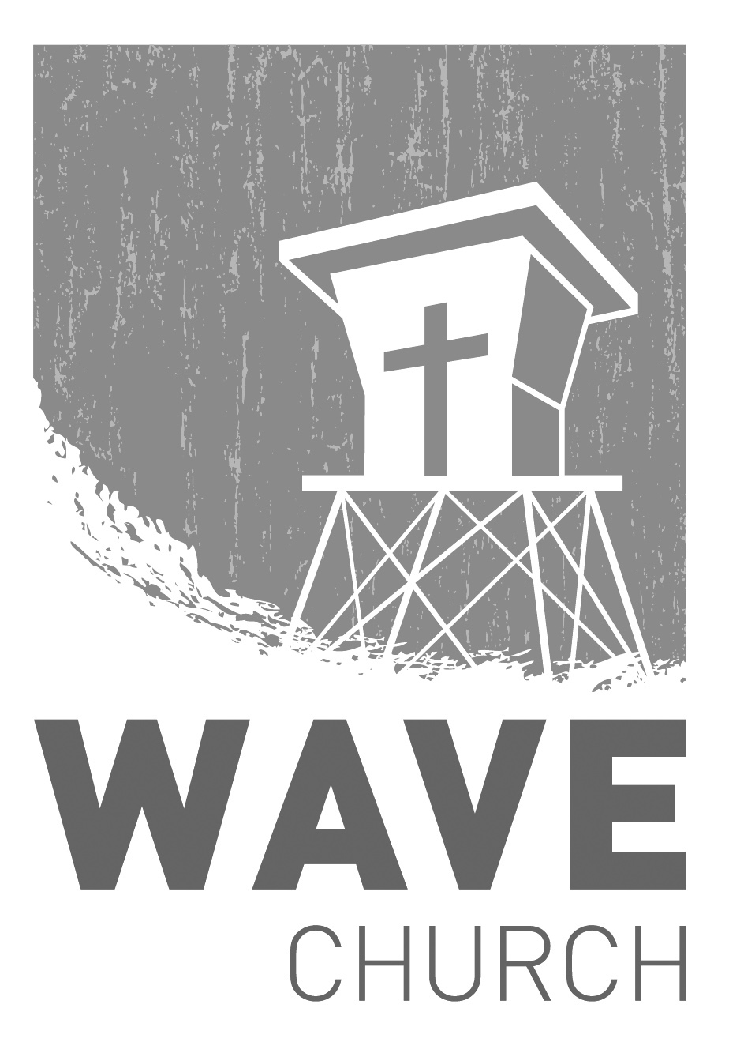
CONNECT.
Connect | Grow | Serve

Sundays at 10 a.m.
Willow Grove Elementary
14727 Via Azul
San Diego, CA | 92127
858-859-2831
Wavechurchsd.com
Wave Church

Welcome to

.
CONNECT SUNDAY | TODAY!
Join us right after church to celebrate our newly dedicated babies, connect
with one another, and enjoy some street tacos!

WAVE WEEKLY NEWSLETTER
Want to keep up with all that is going on at Wave? Simply fill out your communication card and write ‘Newsletter’ to get a weekly email update
from Wave!
GROW.
.
SERMON PODCASTS | wavechurchsd.com/sermons/
Have you missed a few sermons recently? If you have been waylaid by viruses, or are traveling and can’t make it to church, don’t despair -- our sermons are available online! Want to hear a section again, or send it to a friend? Download our sermon podcasts at http://wavechurchsd.com/sermons/
SERVE.
.
WE NEED YOUR HELP | Serve Teams
We have a few service teams who are looking for more volunteers. Are you part of a serve team yet? Or would you like to try something new? Serving is a great way to make new connections, while making a difference in our church body. Please fill out a connection card with your name and the area you would be willing to serve, and a team leader will be in touch with you!

- Hospitality: Greeters
- Audio/Visual: Slides
- Kids Ministry: Classroom volunteers

