PARABLE OF THE WHEAT AND TARES | MATTHEW 13
WAVE CHURCH SD | MARCH 24, 2019

WHAT TO KNOW ABOUT PARABLES…

- AN ILLUSTRATION OF A CENTRAL TRUTH ABOUT THE KINGDOM OF GOD

- PARABLES ARE NOT ALLEGORIES

- THEIR PRIMARY PURPOSE IS TO BOTH CONCEAL AND REVEAL

Matthew 13:24-43 (ESV)
²⁴ He put another parable before them, saying, “The kingdom of heaven may be compared to a man who sowed good seed in his field, ²⁵ but while his men were sleeping, his enemy came and sowed weeds among the wheat and went away. ²⁶ So when the plants came up and bore grain, then the weeds appeared also. ²⁷ And the servants of the master of the house came and said to him, ‘Master, did you not sow good seed in your field? How then does it have weeds?’ ²⁸ He said to them, ‘An enemy has done this.’ So the servants said to him, ‘Then do you want us to go and gather them?’ ²⁹ But he said, ‘No, lest in gathering the weeds you root up the wheat along with them. ³⁰ Let both grow together until the harvest, and at harvest time I will tell the reapers, “Gather the weeds first and bind them in bundles to be burned, but gather the wheat into my barn.” ’ ” ³¹ He put another parable before them, saying, “The kingdom of heaven is like a grain of mustard seed that a man took and sowed in his field. ³² It is the smallest of all seeds, but when it has grown it is larger than all the garden plants and becomes a tree, so that the birds of the air come and make nests in its branches.” ³³ He told them another parable. “The kingdom of heaven is like leaven that a woman took and hid in three measures of flour, till it was all leavened.” ³⁴ All these things Jesus said to the crowds in parables; indeed, he said nothing to them without a parable. ³⁵ This was to fulfill what was spoken by the prophet: “I will open my mouth in parables; I will utter what has been hidden since the foundation of the world.” ³⁶ Then he left the crowds and went into the house. And his disciples came to him, saying, “Explain to us the parable of the weeds of the field.” ³⁷ He answered, “The one who sows the good seed is the Son of Man. ³⁸ The field is the world, and the good seed is the sons of the kingdom. The weeds are the sons of the evil one, ³⁹ and the enemy who sowed them is the devil. The harvest is the end of the age, and the reapers are angels. ⁴⁰ Just as the weeds are gathered and burned with fire, so will it be at the end of the age. ⁴¹ The Son of Man will send his angels, and they will gather out of his kingdom all causes of sin and all law-breakers, ⁴² and throw them into the fiery furnace. In that place there will be weeping and gnashing of teeth. ⁴³ Then the righteous will shine like the sun in the kingdom of their Father. He who has ears, let him hear.
CENTRAL TRUTH OF THE PARABLE OF THE WHEAT AND TARES

- IN THIS WORLD, THERE ARE THOSE WHO ARE GOOD AND THOSE WHO ARE EVIL.

- IT IS NOT OUR JOB TO JUDGE THE GOOD FROM THE EVIL.

- WHEN WE TAKE ON THE TASK OF JUDGING, WE UNINTENTIONALLY HURT THE HARVEST.

HOW ARE WE SUPPOSED TO RESPOND TO…

NON-CHRISTIANS

- DO NOT AVOID THEM | 1 Corinthians 5:9-13

- DO NOT ATTACK THEM | 2 Timothy 2:24-26

CHRISTIANS WITH ISSUES

WACKADO THEOLOGY

- FOCUS ON THE MAJORS

- DON’T PLATFORM BAD THEOLOGY | Acts 17:11, 2 John 1:9-11

- DON'T GO HERESY HUNTING | John 13:35

HIGH-HANDED SIN

- LOOK IN THE MIRROR | Matt 7:1-4

- GENTLY CORRECT | Matt 7:5

- DON'T ASSOCIATE | Matt 7:6

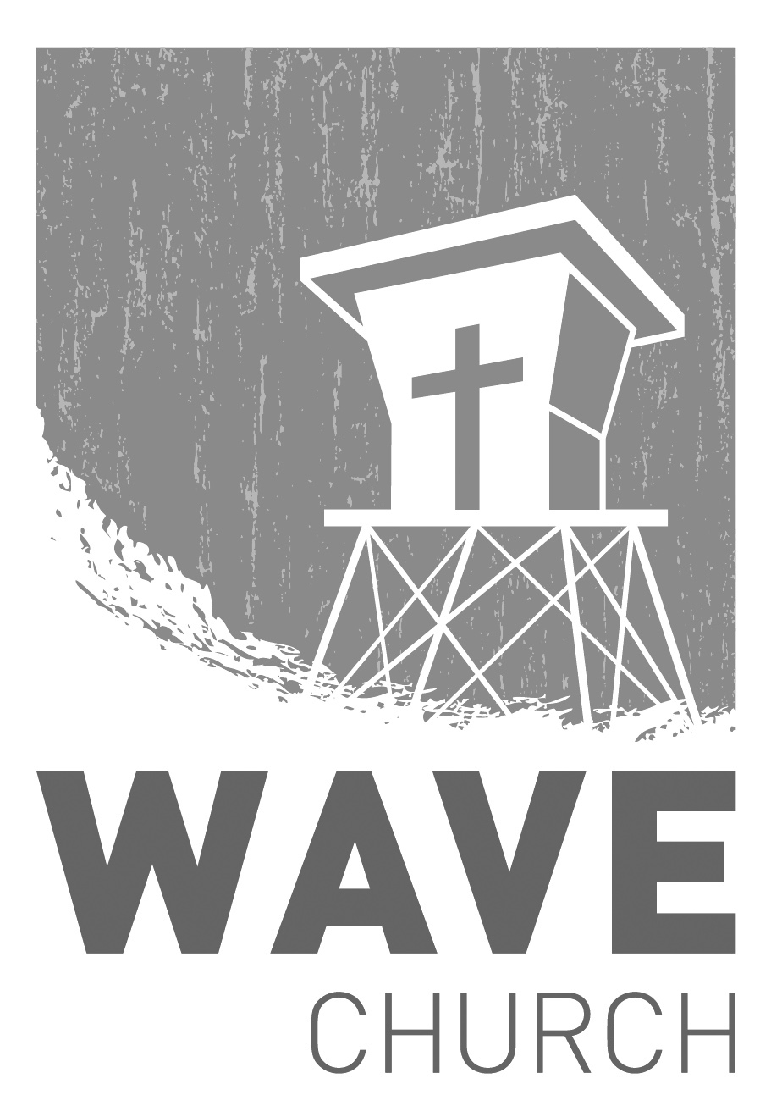
CONNECT.
Connect | Grow | Serve

Sundays at 10 a.m.
Willow Grove Elementary
14727 Via Azul
San Diego, CA | 92127
858-859-2831
Wavechurchsd.com
Wave Church

Welcome to

.
CONNECT SUNDAY + BABY DEDICATION | Mar. 31st
Wave has been blessed many times over with new babies in the past year,
and it is both a blessing to those families and to our church as a whole. Join us as we celebrate these little lives, praying that they will have huge impacts for the kingdom of Christ. If you are interested in having your child dedicated to the Lord, please email us at info@wavechurchsd.com.

WAVE WEEKLY NEWSLETTER
Want to keep up with all that is going on at Wave? Simply fill out your communication card and write ‘Newsletter’ to get a weekly email update
from Wave!
GROW.
.
MARRIAGE STRONG CLASS | Begins Mar. 27th
For those who have signed up for the Marriage Strong class with Steven, just a reminder that class starts next week, March 27th. Look for a welcome email in the upcoming week from Steven with location information.

SERMON PODCASTS | wavechurchsd.com/sermons/
Have you missed a few sermons recently? If you have been waylaid by viruses, or are traveling and can’t make it to church, don’t despair -- our sermons are available online! Want to hear a section again, or send it to a friend? Download our sermon podcasts at http://wavechurchsd.com/sermons/
SERVE.
.
WE NEED YOUR HELP | Serve Teams
We have a few service teams who are looking for more volunteers. Are you part of a serve team yet? Or would you like to try something new? Serving is a great way to make new connections, while making a difference in our church body. Please fill out a connection card with your name and the area you would be willing to serve, and a team leader will be in touch with you!

- Hospitality: Greeters
- Audio/Visual: Slides
- Kids Ministry: Classroom volunteers

