`THE PARABLE OF THE TREASURES | MATTHEW 13
WAVE CHURCH SD | MARCH 17, 2019

Matthew 13:10-13 (ESV) ¹⁰ Then the disciples came and said to him, “Why do you speak to them in parables?” ¹¹ And he answered them, “To you it has been given to know the secrets of the kingdom of heaven, but to them it has not been given. ¹² For to the one who has, more will be given, and he will have an abundance, but from the one who has not, even what he has will be taken away. ¹³ This is why I speak to them in parables, because seeing they do not see, and hearing they do not hear, nor do they understand.

WHAT IS THE KINGDOM OF HEAVEN?

- THE KINGDOM OF HEAVEN IS THE REALM IN WHICH JESUS IS THE UNDISPUTED KING.

Luke 17:20-21, Matthew 6:10

HOW MUCH DOES IT COST FOR KINGDOM ENTRANCE?

- PERFECTION | Matthew 5:48

- FAITH IN A PERFECT SAVIOR | Isaiah 64:6, 2 Cor. 5:21, Rom. 5:8

GENUINE FAITH NEVER FAILS TO APPRECIATE THE TRUE COST OF SALVATION

Matthew 5:3 (ESV) “Blessed are the poor in spirit, for theirs is the kingdom of heaven.

Matthew 13:44-46 (ESV) ⁴⁴ “The kingdom of heaven is like treasure hidden in a field, which a man found and covered up. Then in his joy he goes and sells all that he has and buys that field. ⁴⁵ “Again, the kingdom of heaven is like a merchant in search of fine pearls, ⁴⁶ who, on finding one pearl of great value, went and sold all that he had and bought it.

SIX TRUTHS ABOUT THE KINGDOM

- THE KINGDOM IS PRICELESS IN VALUE | Phil. 3:7-8, 1 Peter 1:4

- THE KINGDOM IS NOT SUPERFICIALLY VISIBLE | Matt 7:7-8

- THE KINGDOM IS PERSONAL | Romans 2:28-29

- THE KINGDOM IS THE TRUE SOURCE OF REAL JOY | John 15:11

- NOT EVERYONE COMES TO THE KINGDOM IN THE SAME WAY

- SAVING FAITH HAS A HIGH COST | Matthew 10:37-39

THREE QUESTIONS:

- DO WE UNDERSTAND THE VALUE OF WHAT WE HAVE?

- DO WE SEE OUR CHRISTIAN LIFE AS WHAT WE LOSE OR GAIN?
“He is no fool who gives what he cannot keep to gain what he cannot lose.” – Jim Elliot

- WHERE DO WE LOOK RIDICULOUS IF THERE IS NO TREASURE?
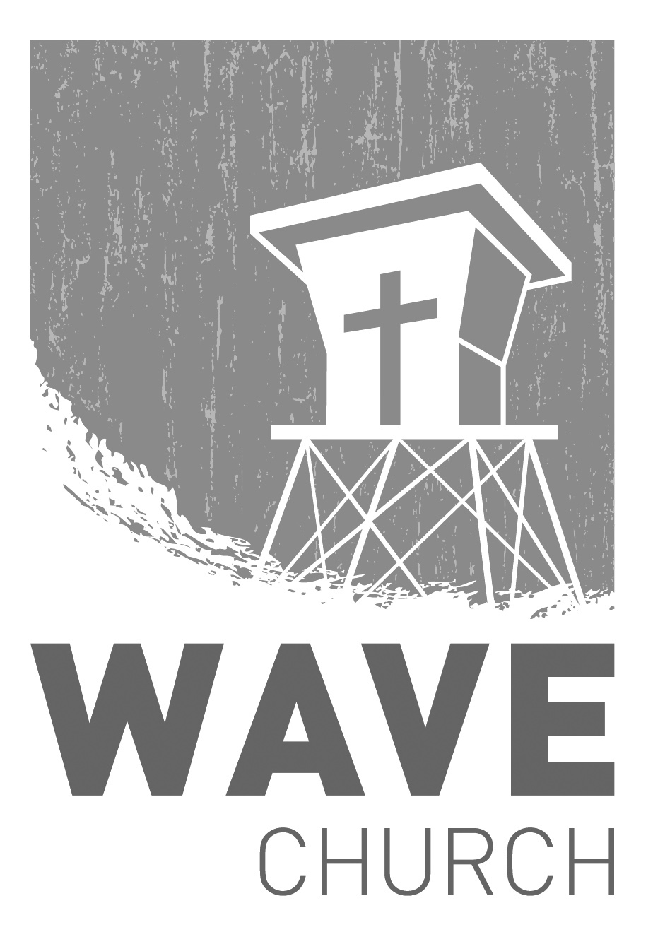
CONNECT.
Connect | Grow | Serve

Sundays at 10 a.m.
Willow Grove Elementary
14727 Via Azul
San Diego, CA | 92127
858-859-2831
Wavechurchsd.com
Wave Church

Welcome to

.
BABY DEDICATION + CONNECT SUNDAY | Mar. 31th
Wave has been blessed many times over with new babies in the past year, and it is both a blessing to those families and to our church as a whole. Join us as we celebrate these little lives, praying that they will have huge impacts for the kingdom of Christ. If you are interested in having your child dedicated to the Lord, please email us at info@wavechurchsd.com.

After church, we invite you to stay for Connect Sunday to celebrate our newly dedicated babies, and join us for street tacos in the outdoor cafeteria!

WAVE WEEKLY NEWSLETTER
Want to keep up with all that is going on at Wave? Simply fill out your communication card and write ‘Newsletter’ to get a weekly email update
from Wave!
GROW.
.
MARRIAGE STRONG CLASS | Begins Mar. 27th
In this four-week class, you will learn to discover the truth about marriage,
and how the past affects your relationships; identify your conflict patterns,
turning destructive coping into positive interaction with your spouse; and embrace your personality differences and diverse spiritual gifts, and learn to encourage each other in spiritual and emotional growth. Wednesdays from
7 to 9 p.m. For more information, please fill out a communication card.
SERVE.
.
WE NEED YOUR HELP | Serve Teams
We have a few service teams who are looking for more volunteers. Are you part of a serve team yet? Or would you like to try something new? Serving is a great way to make new connections, while making a difference in our church body. Please fill out a connection card with your name and the area you would be willing to serve, and a team leader will be in touch with you!

- Hospitality: Greeters
- Audio/Visual: Slides
- Kids Ministry: Classroom volunteers

