THE VOW | THE VOW OF PURITY
WAVE CHURCH SD | MARCH 3 , 2019

VOW OF PRIORITY: GOD IS MY ONE, MY SPOUSE IS MY TWO
VOW OF PURSUIT: I WILL ALWAYS PURSUE MY TWO
VOW OF PARTNERSHIP: I PROMISE MY MARRIAGE WILL BE ABOUT WE
AND NOT ABOUT ME

IT IS DIFFICULT TO BUILD A LIFE OF RIGHTEOUSNESS ON A FOUNDATION OF SIN

Genesis 2:24-25 (ESV) ²⁴ Therefore a man shall leave his father and his mother and hold fast to his wife, and they shall become one flesh. ²⁵ And the man and his wife were both naked and were not ashamed.

- Shame: buwsh (boosh); to be ashamed, to feel completely worthless

Genesis 3:6-10 (ESV) ⁶ So when the woman saw that the tree was good for food, and that it was a delight to the eyes, and that the tree was to be desired to make one wise, she took of its fruit and ate, and she also gave some to her husband who was with her, and he ate. ⁷ Then the eyes of both were opened, and they knew that they were naked. And they sewed fig leaves together and made themselves loincloths. ⁸ And they heard the sound of the Lord God walking in the garden in the cool of the day, and the man and his wife hid themselves from the presence of the Lord God among the trees of the garden. ⁹ But the Lord God called to the man and said to him, “Where are you?” ¹⁰ And he said, “I heard the sound of you in the garden, and I was afraid, because I was naked, and I hid myself.”

- SHAME IS SATAN’S TOOL OF CONNECTING THE ACT TO THE IDENTITY

- SECRECY IS THE ENEMY OF INTIMACY

THE VOW OF PURITY

I PROMISE TO CONFIDE IN YOU AND NOT HIDE FROM YOU

Ephesians 5:7-11 (NIV) Let no one deceive you with empty words, for because of such things God’s wrath comes on those who are disobedient. ⁷ Therefore do not be partners with them. ⁸ For you were once darkness, but now you are light in the Lord. Live as children of light⁹ (for the fruit of the light consists in all goodness, righteousness and truth) ¹⁰ and find out what pleases the Lord. ¹¹ Have nothing to do with the fruitless deeds of darkness, but rather expose them.

- SHAME GROWS IN THE DARK, HEALING HAPPENS IN THE LIGHT

Ephesians 5:3, Matthew 5:27-30 (NIV), Proverbs 5:8 (NIV)

HOW TO LIVE IN THE LIGHT

- BE AN INTENTIONAL CONSUMER

Psalm 119:9(NIV) 9 How can a young person stay on the path of purity? By living according to your word. 10 I seek you with all my heart; do not let me stray from your commands. 11 I have hidden your word in my heart that I might not sin against you.

- MAKE EVERYTHING VISIBLE

1 John 1:7 (NIV) ⁷ But if we walk in the light, as he is in the light, we have fellowship with one another, and the blood of Jesus, his Son, purifies us from all sin.

- CONFESS QUICKLY

Proverbs 28:13 (NIV) 13 Whoever conceals their sins does not prosper, but the one who confesses and renounces them finds mercy.

1 John 1:9 (NIV) ⁸ If we claim to be without sin, we deceive ourselves and the truth is not in us. ⁹ If we confess our sins, he is faithful and just and will forgive us our sins and purify us from all unrighteousness.

CONNECT.
.
MARRIAGE STRONG CLASS | Begins March 27th
In this four-week class you will learn to discover the truth about marriage and how the past affects your relationships; Identify your conflict patterns and turn destructive coping into positive interaction with your spouse; Embrace your personality differences and diverse spiritual gifts and learn to encourage each other in spiritual and emotional growth. Wednesdays from 7-9pm. For more information please fill out a communication card.
THE PARABLES OF JESUS | Begins Mar. 10C
Connect | Grow | Serve

Everyone loves an unforgettable story. Especially when that story captures our hearts, sucks us in, and changes us forever! The Parables of Jesus are famous, unforgettable, and often confusing; yet these spontaneous tales are meant to teach us intentional lessons that have the power to transform. Join us as we discover the true meaning of the Parables of Jesus.
WAVE WEEKLY NEWSLETTER
Want to keep up with all that is going on at Wave? Simply fill out your communication card and write ‘Newsletter’ to get a weekly email update
from Wave!
GROW.
.
LIFE GROUP STUDY GUIDE | wavechurchsd.com/study/
Our Life Group Study Guides are available online! The study guide will help you unpack what you heard on Sunday, while diving deeper into God's word during your group discussions, or as a time of personal reflection.
http://wavechurchsd.com/study/
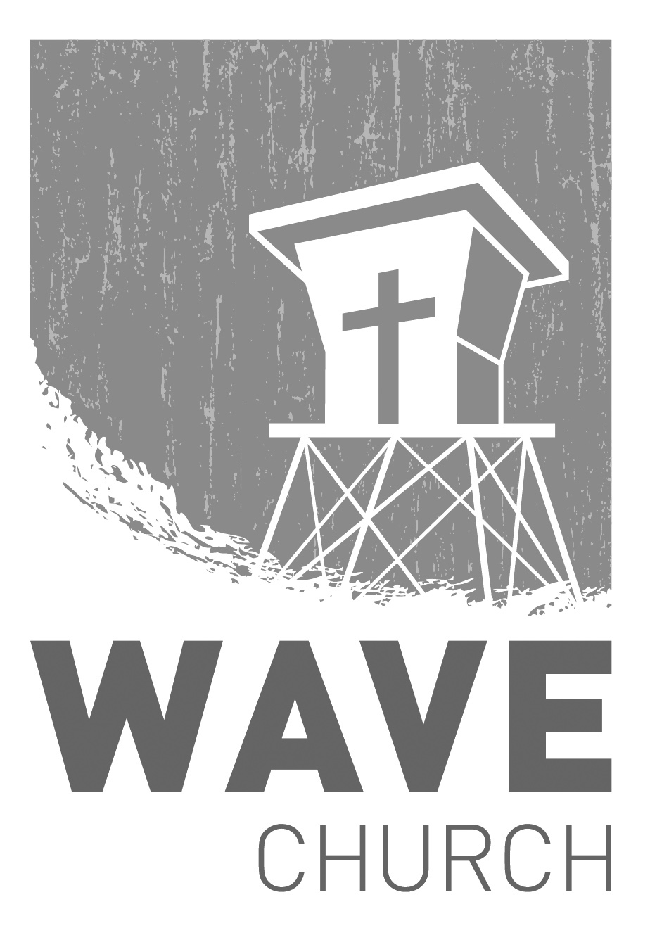
SERVE.
Sundays at 10 a.m.
Willow Grove Elementary
14727 Via Azul
San Diego, CA | 92127
858-859-2831
Wavechurchsd.com
.
WE NEED YOUR HELP | Serve Teams
We have a few service teams who are looking for more volunteers. Are you part of a serve team yet? Or would you like to try something new? Serving is a great way to make new connections, while making a difference in our church body. Please fill out a connection card with your name and the area you would be willing to serve, and a team leader will be in touch with you!
- Hospitality: Greeters
- Audio/Visual: Slides
- Kids Ministry: Classroom volunteers

Wave Church

Welcome to

