COLOSSIANS | A PRAYER FOR THE CHURCH
Colossians 1:9-14 | JULY 7TH, 2019

JESUS IS GREATER!

Colossians 1:9 (ESV) ⁹ And so, from the day we heard, we have not ceased to pray for you, asking that you may be filled with the knowledge of his will in all spiritual wisdom and understanding…

Romans 12:1-2 (ESV) Therefore, I urge you, brothers and sisters, in view of God’s mercy, to offer your bodies as a living sacrifice, holy and pleasing to God—this is your true and proper worship. ² Do not conform to the pattern of this world, but be transformed by the renewing of your mind. Then you will be able to test and approve what God’s will is—his good, pleasing and perfect will.

SANCTIFICATION:
THE PROCESS OF BECOMING MORE LIKE JESUS (HOLY)

THE MOMENT WE PROFESS FAITH IN CHRIST IS THE STARTING LINE, NOT THE FINISH LINE.

Hebrews 12:1-2 (ESV) Therefore, since we are surrounded by so great a cloud of witnesses, let us also lay aside every weight, and sin which clings so closely, and let us run with endurance the race that is set before us, ² looking to Jesus, the founder and perfecter of our faith, who for the joy that was set before him endured the cross, despising the shame, and is seated at the right hand of the throne of God.

SPIRITUAL WISDOM COMES AFTER WE FOLLOW.

1 Corinthians 3:1-2 (ESV) But I, brothers, could not address you as spiritual people, but as people of the flesh, as infants in Christ. ² I fed you with milk, not solid food, for you were not ready for it. And even now you are not yet ready,

Colossians 1:10-14 (ESV) ¹⁰ so as to walk in a manner worthy of the Lord,
fully pleasing to him: bearing fruit in every good work and increasing in the knowledge of God; ¹¹ being strengthened with all power, according to his glorious might, for all endurance and patience with joy; ¹² giving thanks to the Father, who has qualified you to share in the inheritance of the saints in light. ¹³ He has delivered us from the domain of darkness and transferred us to the kingdom of his beloved Son, ¹⁴ in whom we have redemption, the forgiveness of sins.

HOW TO PLEASE THE LORD

- BEAR FRUIT | John 15:5-8

- INCREASE IN YOUR KNOWLEDGE OF GOD | Prov. 9:10, Jer. 9:23-24

- PATIENTLY ENDURE WITH JOY | James 1:2-4

- GIVE GOD THE GLORY | Colossians 3:17

THOSE WHO LEAVE EVERYTHING IN GOD’S HANDS WILL EVENTUALLY SEE GOD’S HANDS IN EVERYTHING.

THE MOST IMPORTANT THING IN YOUR LIFE
IS WHAT YOU BELIEVE ABOUT GOD!

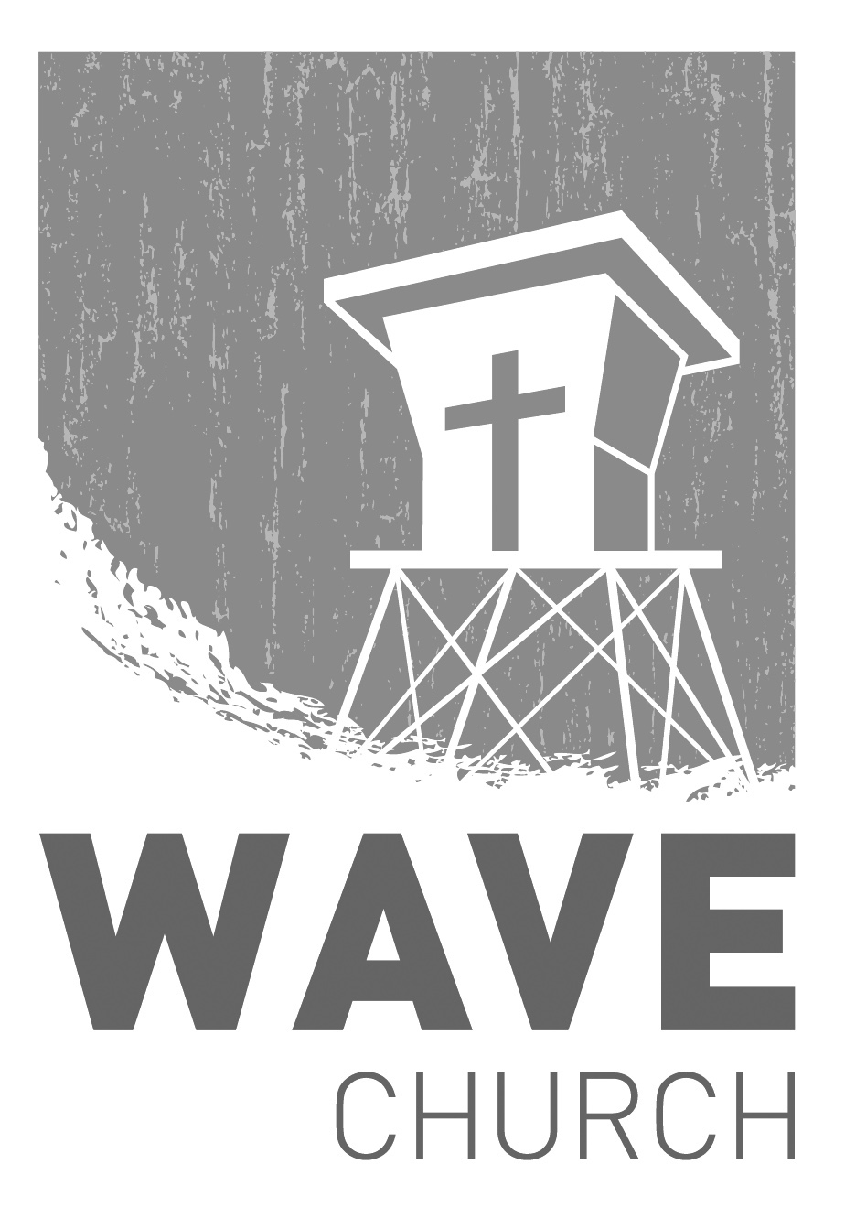
CONNECT.
Connect | Grow | Serve

Wave Church

Welcome to

Sundays at 10 a.m.
Willow Grove Elementary
14727 Via Azul
San Diego, CA | 92127
858-859-2831
Wavechurchsd.com
.
STARTING POINT | TODAY
We are hosting a Starting Point lunch today, right after church. If you would like to learn more about Wave, meet our pastors, staff, and other newcomers, then join us for a family meal, and hear about the story and heart of our church.

WAVE WEEKLY NEWSLETTER
Want to keep up with all that is going on at Wave? Simply fill out your communication card and write ‘Newsletter’ to get a weekly email update
from Wave!
GROW.
.
SERMON PODCASTS | wavechurchsd.com/sermons/
Summer is in full swing – although no one has told the weather! Many of us
will be traveling and can’t make it to church, but you can still keep up with our sermons online! Want to hear a section again, or send it to a friend? Download our sermon podcasts at http://wavechurchsd.com/sermons/
SERVE.
.
WAVE FAMILY CAMP | Aug. 8-10, 2019
We will be traveling to La Misión, Mexico for a two-night, three-day family missions trip at Door of Faith Orphanage. During our time there, we will be spending time with the kids, serving meals, and helping prepare a space for Door of Faith's new school! Making quality connections is what missions are all about, so please bring your whole family! For more information, and to register, check the Newsletter or visit our website. Hope to see you there!
WE NEED YOUR HELP | Serve Teams
We have a few service teams who are looking for more volunteers. Are you part of a serve team yet? Or would you like to try something new? Serving is a great way to make new connections, while making a difference in our church body. Please fill out a connection card with your name and the area you would be willing to serve, and a team leader will be in touch with you!

- Hospitality: Greeters
- Audio/Visual: Slides
- Kids Ministry: Classroom volunteers

