WHEN THE DEVIL KNOCKS | THE DESTROYER
WAVE CHURCH SD | JUNE 23, 2019

1 Peter 5:8-11 (ESV) ⁸ Be alert and of sober mind. Your enemy the devil prowls around like a roaring lion looking for someone to devour. ⁹ Resist him, standing firm in the faith, because you know that the family of believers throughout the world is undergoing the same kind of sufferings. ¹⁰ And the God of all grace, who called you to his eternal glory in Christ, after you have suffered a little while, will himself restore you and make you strong, firm and steadfast. ¹¹ To him be the power for ever and ever. Amen.

- SATAN IS A DECEIVER WHO ATTACKS OUR MINDS WITH LIES.

- SATAN IS AN ACCUSER WHO FILLS OUR HEARTS WITH ACCUSATIONS.

- SATAN IS THE DESTROYER WHO ATTACKS OUR WILL WITH PRIDE.

Matthew 22:37 (ESV) ³⁷ And he said to him, “You shall love the Lord your God with all your heart and with all your soul and with all your mind and with all of your strength.

Isaiah 14:12-14 (ESV) ¹² “How you are fallen from heaven, O Day Star, son
of Dawn! How you are cut down to the ground, you who laid the nations low!
¹³ You said in your heart, ‘I will ascend to heaven; above the stars of God I will
set my throne on high; I will sit on the mount of assembly in the far reaches of
the north; ¹⁴ I will ascend above the heights of the clouds; I will make myself like the Most High.’

THE DEVIL ATTACKS NOT JUST IN OUR WEAKNESSES,
BUT IN OUR GREATEST MOMENTS OF STRENGTH.

1 Chronicles 21:1-8 (ESV) Satan rose up against Israel and incited David to take a census of Israel. ² So David said to Joab and the commanders of the troops, “Go and count the Israelites from Beersheba to Dan. Then report back to me so that I may know how many there are.” ³ But Joab replied, “May the Lord multiply his troops a hundred times over. My lord the king, are they not all my lord’s subjects? Why does my lord want to do this? Why should he bring guilt on Israel?” ⁴ The king’s word, however, overruled Joab; so Joab left and went throughout Israel and then came back to Jerusalem. ⁵ Joab reported the number of the fighting men to David: In all Israel there were one million one hundred thousand men who could handle a sword, including four hundred and seventy thousand in Judah. ⁶ But Joab did not include Levi and Benjamin in the numbering, because the king’s command was repulsive to him. ⁷ This command was also evil in the sight of God; so he punished Israel. ⁸ Then David said to God, “I have sinned greatly by doing this. Now, I beg you, take away the guilt of your servant. I have done a very foolish thing.”

YOU ARE NEVER MORE VULNERABLE THAN
WHEN YOU ARE FULL OF PRIDE.

Proverbs 16:18 (NIV) Pride goes before destruction, a haughty spirit before
a fall.

2 Chronicles 26:16-21 (ESV)

James 4:4-10 (ESV) ⁴ You adulterous people! Do you not know that friendship with the world is enmity with God? Therefore whoever wishes to be a friend of the world makes himself an enemy of God. ⁵ … “God opposes the proud but gives grace to the humble.”… ⁷ Submit yourselves therefore to God. Resist the devil, and he will flee from you. ⁸ Draw near to God, and he will draw near to you. Cleanse your hands, you sinners, and purify your hearts, you double-minded. ⁹ Be wretched and mourn and weep. Let your laughter be turned to mourning and your joy to gloom. ¹⁰ Humble yourselves before the Lord, and he will exalt you.

- YOU CANNOT DEFEAT THE DEMONS YOU FLIRT WITH.

PRIDE | I AM INDEPENDENT OF GOD

HUMILITY | I AM DEPENDENT ON GOD

- VICTORY COMES THROUGH SUBMISSION, NOT ELEVATION.

- STOP PLATFORMING YOURSELF, AND START PLATFORMING JESUS.

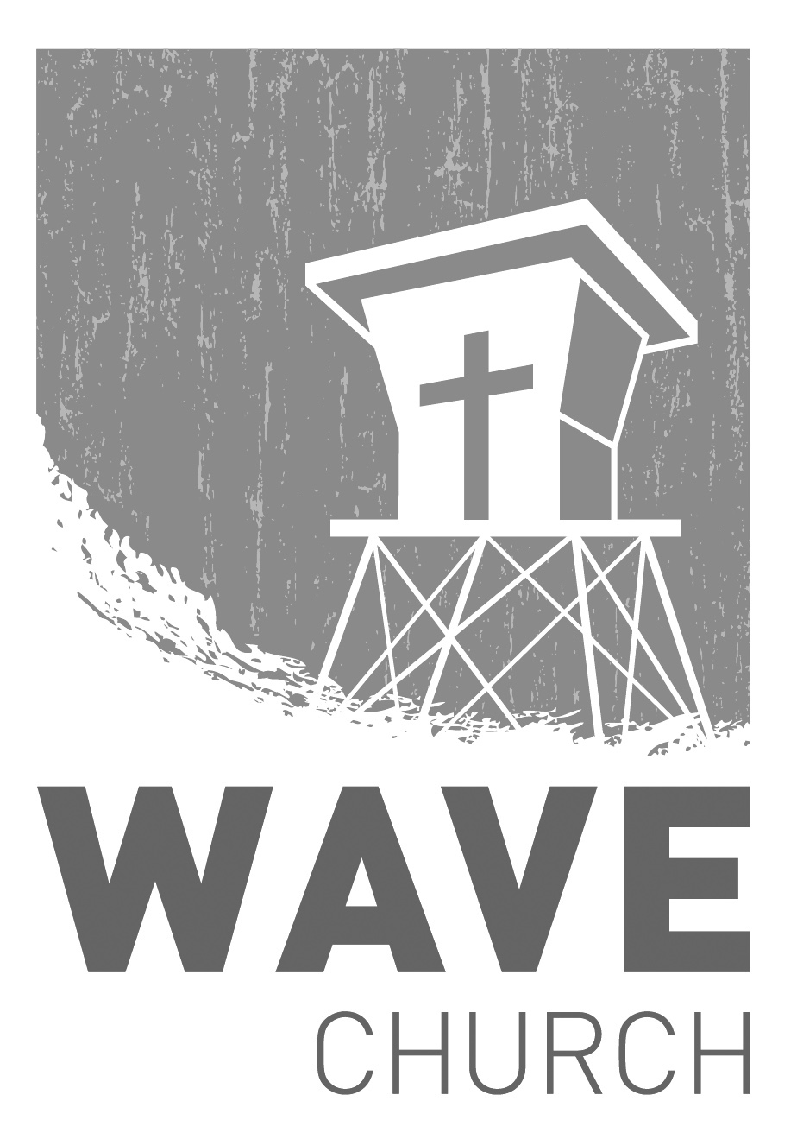
CONNECT.
Connect | Grow | Serve

Wave Church

Welcome to

Sundays at 10 a.m.
Willow Grove Elementary
14727 Via Azul
San Diego, CA | 92127
858-859-2831
Wavechurchsd.com
.
SUMMER KICK-OFF | TODAY!
We are kicking off the summer with Baptisms and an evening at the beach TODAY! We’re meeting at Powerhouse Park in Del Mar at 4 p.m. next to the playground so our kiddos can play and the adults can hang out. Bring a picnic dinner, and stay for an afternoon of fellowship and fun on the beach.
GROW.
.
BAPTISM | TODAY!
Accepting Jesus as your Savior, stepping forward in faith, and pursing a relationship with Him are all parts of our walk with the Lord. Another one of those steps is baptism, which is a public declaration of faith identifying with Christ’s death and resurrection. If you have not been baptized yet, are thinking about it, or want to do it today, come to Powerhouse Park at 4 p.m.!
SERVE.
.
WAVE FAMILY CAMP | Aug. 8-10, 2019
We will be traveling to La Misión, Mexico for a two-night, three-day family missions trip at Door of Faith Orphanage. During our time there, we will be spending time with the kids, serving meals, and helping prepare a space for Door of Faith's new school! Making quality connections is what missions are all about, so please bring your whole family! For more information, and to register, check the Newsletter or visit our website. Hope to see you there!
WE NEED YOUR HELP | Serve Teams
We have a few service teams who are looking for more volunteers. Are you part of a serve team yet? Or would you like to try something new? Serving is a great way to make new connections, while making a difference in our church body. Please fill out a connection card with your name and the area you would be willing to serve, and a team leader will be in touch with you!

- Hospitality: Greeters
- Audio/Visual: Slides
- Kids Ministry: Classroom volunteers

