Upcoming at Wave

CHRISTMAS EVE SERVICE | Dec. 24th
Christmas Eve is a special time at Wave, and we are looking forward to celebrating the birth of Jesus with our church family! Bring your families, invite your neighbors, and come worship with us.
Please note: this is a family service, so there will be no child care.
Join us at 4 p.m. on Monday, December 24th!

REMINDER | Dec. 30th
Sleep in! There is NO church service next week, Dec. 30th. Have a happy and safe new year’s celebration, and we will see you in two weeks!

HOME IMPROVEMENT | Jan. 6TH
See you again in the new year on January 6, 2019, as we kick off our new sermon series, Home Improvement! Join us as we examine how to give our lives and our relationships a spiritual remodel, reminding us that if Jesus is the center of it all, our foundation will be firm.

JOIN A SERVE TEAM TODAY
At Wave Church SD, we deeply value serving one another.
We believe that God designed every person with unique talents and gifts specifically so we can use them to serve Him and others. One
way to fulfill God’s purpose for your life is to discover a place to serve within the church. We currently have need in our children’s ministry and set up ministries. For more information please fill out a communication card and check ‘I want to find a place to serve.’

WAVE WEEKLY NEWSLETTER
Want to keep up with all that is going on at Wave? Simply fill
out your communication card and write ‘Newsletter’ to get
a weekly email update from Wave!

Matching Answers: Portuguese: Feliz Natal; Icelandic: Gleðileg Jól; French: Joyeux Noël; Chinese: Shèngdàn jié kuàilè; German: Fröhliche Weinachten; Russian: счастливого Рождества; Greek: Kala Christouyenna; Romanian: Crăciun fericit; Zulu: Jabulela Ukhisimusi; Italian: Buon Natale

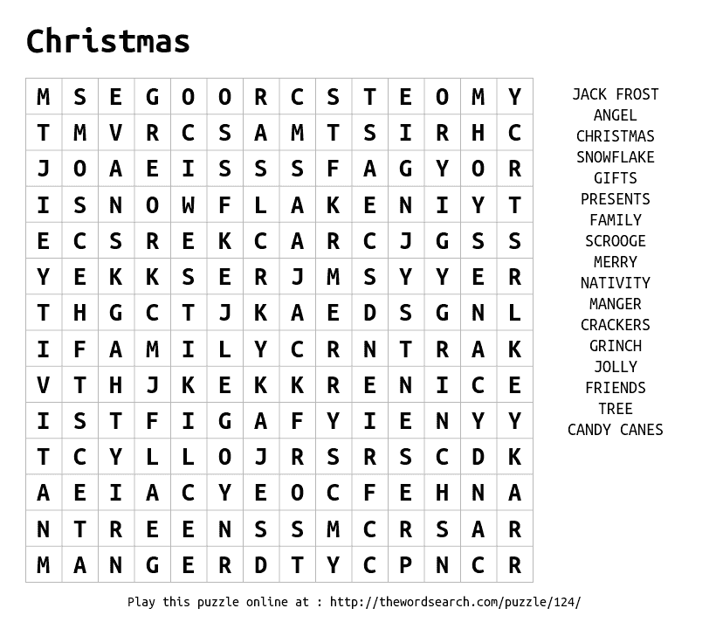
Below is the greeting “Merry Christmas” in 10 different languages.
Can You Match the Language to the Country?
Portuguese | Joyeux Noël
Icelandic | Fröhliche Weinachten
French | Buon Natale
Chinese | Crăciun fericit
German | Feliz Natal
Russian | Kala Christouyenna
Greek | Jabulela Ukhisimusi
Romanian | Gleðileg jól
Zulu (South Africa) | Shèngdàn jié kuàilè
Italian | счастливого Рождества
COME TO WORSHIP | CHRISTMAS EVE 2018
WAVE CHURCH SD | DEC 24, 2018

CHRISTMAS IS AN INVITATION NOT JUST TO ANTICIPATE JOY, BUT TO EXPERIENCE IT!

Luke 2:8-14 (ESV) ⁸ And in the same region there were shepherds out in the field, keeping watch over their flock by night. ⁹ And an angel of the Lord appeared to them, and the glory of the Lord shone around them, and they were filled with great fear. ¹⁰ And the angel said to them, “Fear not, for behold, I bring you good news of great joy that will be for all the people. ¹¹ For unto you is born this day in the city of David a Savior, who is Christ the Lord. ¹² And this will be a sign for you: you will find a baby wrapped in swaddling cloths and lying in a manger.” ¹³ And suddenly there was with the angel a multitude of the heavenly host praising God and saying, ¹⁴ “Glory to God in the highest, and on earth peace among those with whom he is pleased!”

CHRISTMAS IS AN INVITATION NOT JUST TO ANTICIPATE HOPE, BUT TO EXPERIENCE IT!

Luke 2:26-38 (ESV) ²⁶ In the sixth month the angel Gabriel was sent from God to a city of Galilee named Nazareth, ²⁷ to a virgin betrothed to a man whose name was Joseph, of the house of David. And the virgin’s name was Mary. ²⁸ And he came to her and said, “Greetings, O favored one, the Lord is with you!” ²⁹ But she was greatly troubled at the saying, and tried to discern what sort of greeting this might be. ³⁰ And the angel said to her, “Do not be afraid, Mary, for you have found favor with God. ³¹ And behold, you will conceive in your womb and bear a son, and you shall call his name Jesus. ³² He will be great and will be called the Son of the Most High. And the Lord God will give to him the throne of his father David, ³³ and he will reign over the house of Jacob forever, and of his kingdom there will be no end.” ³⁴ And Mary said to the angel, “How will this be, since I am a virgin?” ³⁵ And the angel answered her, “The Holy Spirit will come upon you, and the power of the Most High will overshadow you; therefore the child to be born will be called holy—the Son of God. ³⁶ And behold, your relative Elizabeth in her old age has also conceived a son, and this is the sixth month with her who was called barren. ³⁷ For nothing will be impossible with God.” ³⁸ And Mary said, “Behold, I am the servant of the Lord; let it be to me according to your word.” And the angel departed from her.

CHRISTMAS IS AN INVITATION NOT JUST TO ANTICIPATE PEACE, BUT TO EXPERIENCE IT!

Luke 2:13-20 (ESV) ¹³ And suddenly there was with the angel a multitude of the heavenly host praising God and saying, ¹⁴ “Glory to God in the highest, and on earth peace among those with whom he is pleased!” ¹⁵ When the angels went away from them into heaven, the shepherds said to one another, “Let us go over to Bethlehem and see this thing that has happened, which the Lord has made known to us.” ¹⁶ And they went with haste and found Mary and Joseph, and the baby lying in a manger. ¹⁷ And when they saw it, they made known the saying that had been told them concerning this child. ¹⁸ And all who heard it wondered at what the shepherds told them. ¹⁹ But Mary treasured up all these things, pondering them in her heart. ²⁰ And the shepherds returned, glorifying and praising God for all they had heard and seen, as it had been told them.

John 1:1-5, 9-13 (ESV) In the beginning was the Word, and the Word was with God, and the Word was God. ² He was in the beginning with God. ³ All things were made through him, and without him was not any thing made that was made. ⁴ In him was life, and the life was the light of men. ⁵ The light shines in the darkness, and the darkness has not overcome it… ⁹ The true light, which gives light to everyone, was coming into the world. ¹⁰ He was in the world, and the world was made through him, yet the world did not know him. ¹¹ He came to his own, and his own people did not receive him. ¹² But to all who did receive him, who believed in his name, he gave the right to become children of God, ¹³ who were born, not of blood nor of the will of the flesh nor of the will of man, but of God.

