COLOSSIANS | ALIVE IN CHRIST

Colossians 2:6-15 | AUGUST 11, 2019

Colossians 2:6-15 (NIV) ⁶ So then, just as you received Christ Jesus as Lord, continue to live your lives in him, ⁷ rooted and built up in him, strengthened in the faith as you were taught, and overflowing with thankfulness.
⁸ See to it that no one takes you captive through hollow and deceptive philosophy, which depends on human tradition and the elemental spiritual forces of this world rather than on Christ.
⁹ For in Christ all the fullness of the Deity lives in bodily form, ¹⁰ and in Christ you have been brought to fullness. He is the head over every power and authority. ¹¹ In him you were also circumcised with a circumcision not performed by human hands. Your whole self ruled by the flesh ^{s} was put off when you were circumcised by Christ, ¹² having been buried with him in baptism, in which you were also raised with him through your faith in the working of God, who raised him from the dead.
¹³ When you were dead in your sins and in the uncircumcision of your flesh, God made you alive with Christ. He forgave us all our sins, ¹⁴ having canceled the charge of our legal indebtedness, which stood against us and condemned us; he has taken it away, nailing it to the cross. ¹⁵ And having disarmed the powers and authorities, he made a public spectacle of them, triumphing over them by the cross.

SALVATION IS NOT TRANSACTIONAL, IT IS RELATIONAL.

Galatians 2:20 (ESV) ²⁰ I have been crucified with Christ. It is no longer I who live, but Christ who lives in me. And the life I live in the flesh, I live by faith in the Son of God, who loved me and gave himself for me.

SANCTIFICATION IS NOT ACHIEVED BY ATTAINING, BUT BY ABIDING

John 15:4-5 (ESV) ⁴ Abide in me, and I in you. As the branch cannot bear fruit by itself, unless it abides in me. ⁵ I am the vine; you are the branches. Whoever abides in me bears much fruit, for apart from me you can do nothing.

IT IS OFTEN NOT A LACK OF BELIEF IN JESUS, IT’S A LACK OF BELIEF IN WHAT HE HAS TO SAY ABOUT US.

Genesis 18:12 (ESV) ¹² After I am worn out, and my lord is old, shall I have pleasure?

THANKFULNESS SHAPES OUR VIEW OF GOD.

WHY TRUST WHAT JESUS SAYS?

- HE PUT AN END TO LEGALISM
Colossians 2:9 (ESV)⁹ For in Christ all the fullness of the Deity lives in bodily form, ¹⁰ and in Christ you have been brought to fullness. He is the head over every power and authority.

- HE GIVES US NEW LIFE AND ERASES OUR DEBT
Colossians 2:13-14 (ESV)When you were dead in your sins and in the uncircumcision of your flesh, God made you alive with Christ. He forgave us all our sins, ¹⁴ having canceled the charge of our legal indebtedness, which stood against us and condemned us; he has taken it away, nailing it to the cross

- HE IS PREEMINENT
Colossians 2:15 (ESV) ¹⁵ And having disarmed the powers and authorities, he made a public spectacle of them, triumphing over them by the cross.

WE NEED CHRIST AND CHRIST ALONE
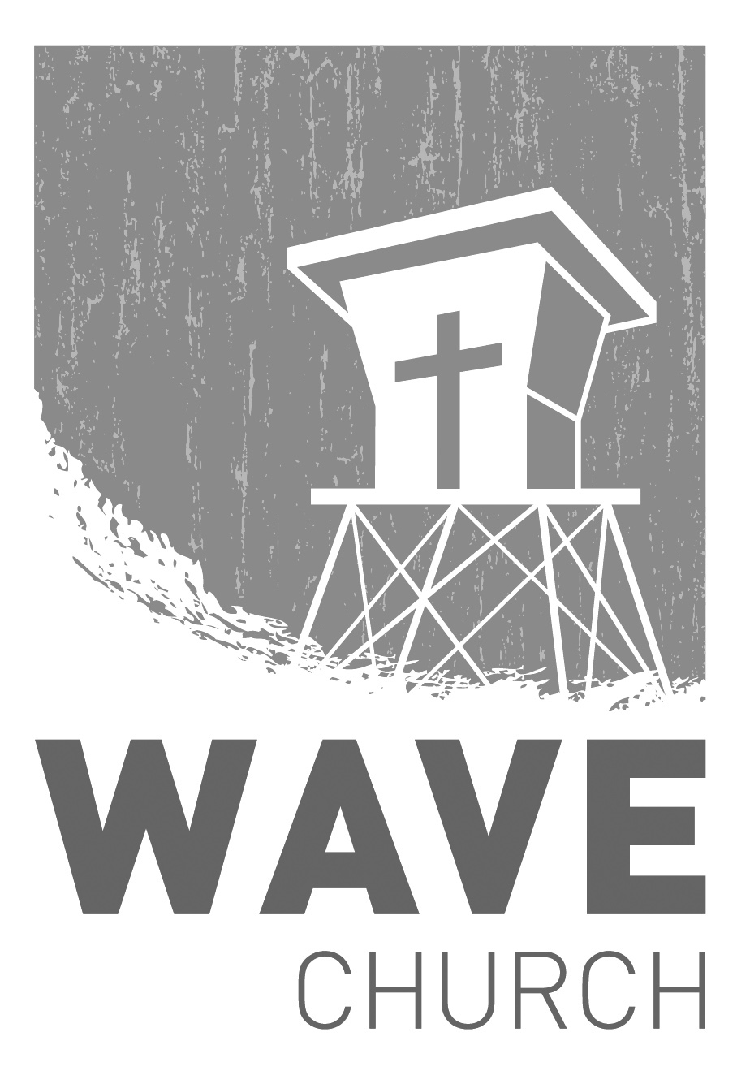
Connect | Grow | Serve

Welcome
to
Wave Church
Sundays at 10 a.m.
Willow Grove Elementary
14727 Via Azul
San Diego, CA | 92127
858-859-2831
Wavechurchsd.com

CONNECT.
.
WAVE WEEKLY NEWSLETTER
Want to keep up with all that is going on at Wave? Simply fill out your communication card and write ‘Newsletter’ to get a weekly email update
from Wave!
GROW.
.
LIFE GROUP SIGN UPS BEGIN | wavechurchsd.com/grow
At Wave, our Life Groups are key to building significant Christian relationships and growing closer to God. The majority of our groups are sermon-based, discussing the previous weekend's message. We also have targeted groups for men and women. Fall session runs from September 9- November 11. For more information please fill out a communication card or email us at info@wavechurchsd.com

SERMON PODCASTS | wavechurchsd.com/sermons/
Summer is in full swing – although no one has told the weather! Many of us
will be traveling and can’t make it to church, but you can still keep up with our sermons online! Want to hear a section again, or send it to a friend? Download our sermon podcasts at http://wavechurchsd.com/sermons/
SERVE.
.
WE NEED YOUR HELP | Serve Teams
We have a few service teams who are looking for more volunteers. Are you part of a serve team yet? Or would you like to try something new? Serving is a great way to make new connections, while making a difference in our church body. Please fill out a connection card with your name and the area you would be willing to serve, and a team leader will be in touch with you!

- Hospitality: Greeters
- Audio/Visual: Slides
- Kids Ministry: Classroom volunteers

