A REASON TO CELEBRATE
WAVE CHURCH SD | APRIL 21, 2019

MATTHEW 28:1-10 (ESV) Now after the Sabbath, toward the dawn of the first day of the week, Mary Magdalene and the other Mary went to see the tomb. ² And behold, there was a great earthquake, for an angel of the Lord descended from heaven and came and rolled back the stone and sat on it. ³ His appearance was like lightning, and his clothing white as snow. ⁴ And for fear of him the guards trembled and became like dead men. ⁵ But the angel said to the women, “Do not be afraid, for I know that you seek Jesus who was crucified. ⁶ He is not here, for he has risen, as he said. Come, see the place where he lay. ⁷ Then go quickly and tell his disciples that he has risen from the dead, and behold, he is going before you to Galilee; there you will see him. See, I have told you.” ⁸ So they departed quickly from the tomb with fear and great joy, and ran to tell his disciples. ⁹ And behold, Jesus met them and said, “Greetings!” And they came up and took hold of his feet and worshiped him. ¹⁰ Then Jesus said to them, “Do not be afraid; go and tell my brothers to go to Galilee, and there they will see me.”

John 2:18-22 (ESV) ¹⁸ So the Jews said to him, “What sign do you show us for doing these things?” ¹⁹ Jesus answered them, “Destroy this temple, and in three days I will raise it up.” ²⁰ The Jews then said, “It has taken forty-six years to build this temple, and will you raise it up in three days?” ²¹ But he was speaking about the temple of his body. ²² When therefore he was raised from the dead, his disciples remembered that he had said this, and they believed the Scripture
and the word that Jesus had spoken.

BECAUSE JESUS HAS RISEN…

- SIN IS DEFEATED

- DEATH HAS BEEN CONQUERED

- SATAN HAS BEEN CRUSHED

Ephesians 2:1-5 (NLT) Once you were dead because of your disobedience and your many sins. ² You used to live in sin, just like the rest of the world, obeying the devil—the commander of the powers in the unseen world. He is the spirit at work in the hearts of those who refuse to obey God. ³ All of us used to live that way, following the passionate desires and inclinations of our sinful nature. By our very nature we were subject to God’s anger, just like everyone else. ⁴ But God is so rich in mercy, and he loved us so much, ⁵ that even though we were dead because of our sins, he gave us life when he raised Christ from the dead. (It is only by God’s grace that you have been saved!)
WHICH MEANS…

YOUR DISAPPOINTMENTS ARE NOT THE END OF YOUR STORY |
ACTS 3:15

THERE IS ALWAYS HOPE IN THE DARK | ROMANS 8:38-39

BROKENNESS WILL BE HEALED | REVELATION 21:3-4, PSALM 56:8

FAITH WILL BE RESTORED | JOHN 20:24-29

DEATH IS NOT THE END | 1 THESSALONIANS 4:13-15

LIFE WILL BE TRANSFORMED | 1 CORINTHIANS 15:51-55

FREEDOM HAS COME | GALATIANS 5:1

NEW LIFE STARTS NOW | 2 CORINTHIANS 5:17-21

THERE IS ALWAYS A REASON TO CELEBRATE | PHILIPPIANS 2:6-11

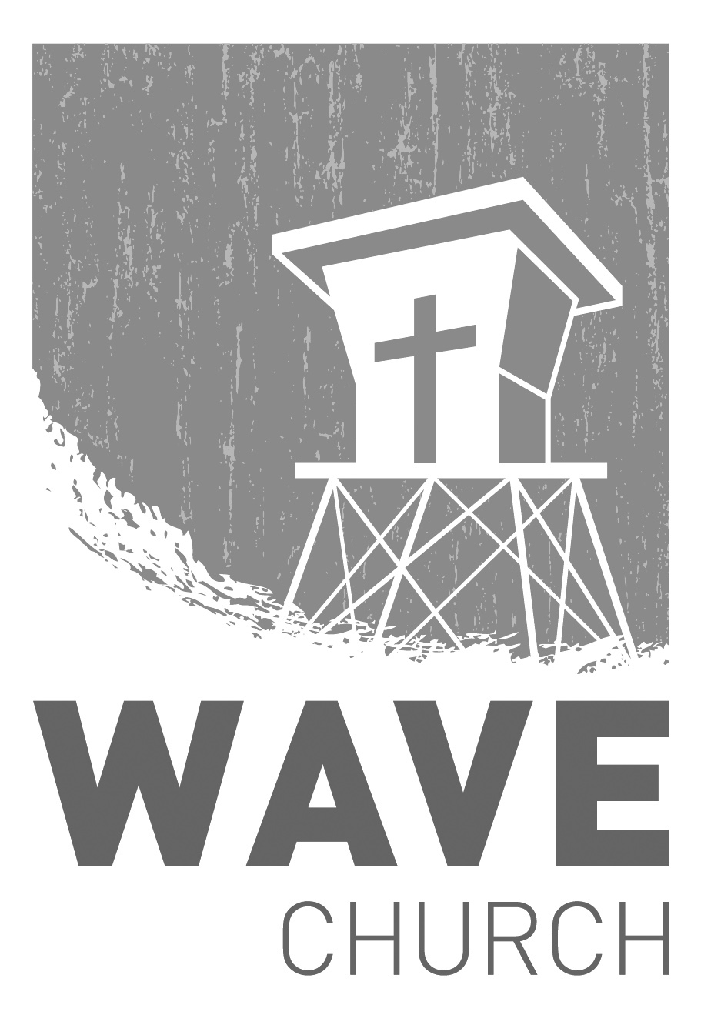
CONNECT.
Connect | Grow | Serve

Sundays at 10 a.m.
Willow Grove Elementary
14727 Via Azul
San Diego, CA | 92127
858-859-2831
Wavechurchsd.com
Wave Church

Welcome to

.
WAVE WEEKLY NEWSLETTER
Want to keep up with all that is going on at Wave? Simply fill out your communication card and write ‘Newsletter’ to get a weekly email update
from Wave!
GROW.
.
SPRING LIFE GROUPS | Begin the Week of Apr. 28th
We are quickly moving through the year, and our next season of Life Groups is starting April 28th! If you have not yet joined a Life Group, please fill out a Life Group info card with your availability, and a Life Group leader will be in touch with you. For those already in Life Groups, we hope you are looking forward to this next season of growth and fellowship!

SERMON PODCASTS | wavechurchsd.com/sermons/
Have you missed a few sermons recently? If you have been waylaid by viruses, or are traveling and can’t make it to church, don’t despair -- our sermons are available online! Want to hear a section again, or send it to a friend? Download our sermon podcasts at http://wavechurchsd.com/sermons/
SERVE.
.
WE NEED YOUR HELP | Serve Teams
We have a few service teams who are looking for more volunteers. Are you part of a serve team yet? Or would you like to try something new? Serving is a great way to make new connections, while making a difference in our church body. Please fill out a connection card with your name and the area you would be willing to serve, and a team leader will be in touch with you!

- Hospitality: Greeters
- Audio/Visual: Slides
- Kids Ministry: Classroom volunteers

