PARABLE OF THE PHARISEE AND THE TAX COLLECTOR
LUKE 18:9-14
WAVE CHURCH SD | APRIL 7, 2019

Luke 18:9-14 (ESV) ⁹ He also told this parable to some who trusted in themselves that they were righteous, and treated others with contempt: ¹⁰ “Two men went up into the temple to pray, one a Pharisee and the other a tax collector. ¹¹ The Pharisee, standing by himself, prayed thus: ‘God, I thank you that I am not like other men, extortioners, unjust, adulterers, or even like this tax collector. ¹² I fast twice a week; I give tithes of all that I get.’ ¹³ But the tax collector, standing far off, would not even lift up his eyes to heaven, but beat his breast, saying, ‘God, be merciful to me, a sinner!’ ¹⁴ I tell you, this man went down to his house justified, rather than the other. For everyone who exalts himself will be humbled, but the one who humbles himself will be exalted.”

THIS PARABLE POINTS US TO ONE OF LIFE’S
GREATEST QUESTIONS: WHO AM I?

TWO MEN ENTER…

- THE PHARISEE IS THE MODEL OF RELIGIOUS PERFECTION

- THE TAX COLLECTOR IS THE MODEL OF A SINFUL OUTCAST

THE POWER OF PRAYER…

THE TAX COLLECTOR UNDERSTOOD WHO GOD IS
AND WHO HE WAS.

- UP FRONT VS. IN THE BACK

  - Matthew 6:5 (ESV) “And when you pray, do not be like the hypocrites, for they love to pray standing in the synagogues and on the street corners to be seen by others. Truly I tell you, they have received their reward in full.

- STANDING VS. KNEELING

  - Revelation 1:17 (ESV) When I saw him, I fell at his feet as though dead. But he laid his right hand on me, saying, “Fear not, I am the first and the last,
- ARRIVED VS. IN PROCESS

  - Luke 9:23 (ESV) And he said to all, “If anyone would come after me, let him deny himself and take up his cross daily and follow me.

MORE THAN A PARABLE ON PRAYER,
BUT A PARABLE OF JUSTIFICATION

Justification: The act of God in bringing sinners into a new covenant relationship with Himself through the forgiveness of sins.

MADE RIGHT…

- THROUGH FAITH ALONE

  - Romans 3:23, 28 (ESV) ²³for all have sinned and fall short of the glory of God… ²⁸ For we hold that one is justified by faith apart from works of the law.

- GIVEN, NOT EARNED

  - Ephesians 2:8-9 (ESV) ⁸ For it is by grace you have been saved, through faith—and this is not from yourselves, it is the gift of God— ⁹ not by works, so that no one can boast.

- IT HAPPENS IMMEDIATELY

SO, WHO AM I?

- THE TWIST IN THE PARABLE IS WE WANT TO BE THE SINNER; THE TRUTH IS THAT WE ALREADY ARE.

  - Romans 5:8 (ESV) but God shows his love for us in that while we were still sinners, Christ died for us.

  - Romans 8:1 (ESV) There is therefore now no condemnation for those who are in Christ Jesus.
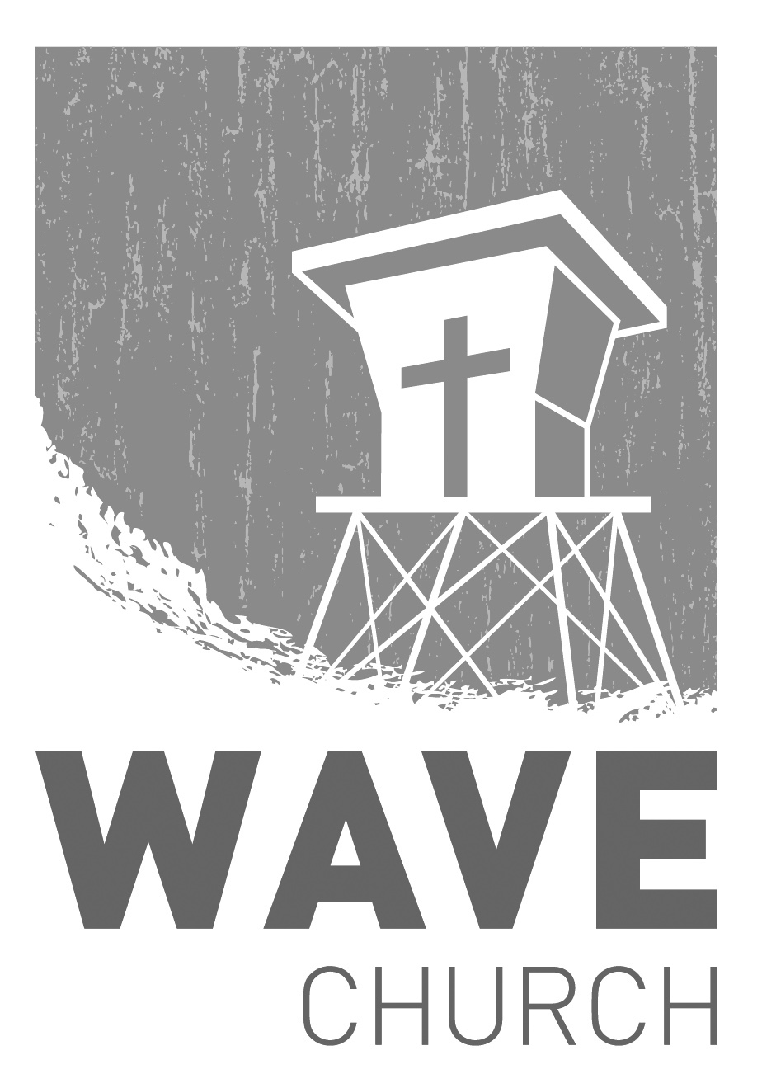
CONNECT.
Connect | Grow | Serve

Sundays at 10 a.m.
Willow Grove Elementary
14727 Via Azul
San Diego, CA | 92127
858-859-2831
Wavechurchsd.com
Wave Church

Welcome to

.
EASTER CHOIR | April 21st
Easter is a special time of celebration at Wave. This year, we would love to open our service with an Easter Choir – and we need your voice! No solos,
no pressure -- just a heart for praise and worship. Please contact Tiffany Goodrick at tiffanygoodrick@gmail.com to let her know if you're interested!

WAVE WEEKLY NEWSLETTER
Want to keep up with all that is going on at Wave? Simply fill out your communication card and write ‘Newsletter’ to get a weekly email update
from Wave!
GROW.
.
SERMON PODCASTS | wavechurchsd.com/sermons/
Have you missed a few sermons recently? If you have been waylaid by viruses, or are traveling and can’t make it to church, don’t despair -- our sermons are available online! Want to hear a section again, or send it to a friend? Download our sermon podcasts at http://wavechurchsd.com/sermons/
SERVE.
.
WE NEED YOUR HELP | Serve Teams
We have a few service teams who are looking for more volunteers. Are you part of a serve team yet? Or would you like to try something new? Serving is a great way to make new connections, while making a difference in our church body. Please fill out a connection card with your name and the area you would be willing to serve, and a team leader will be in touch with you!

- Hospitality: Greeters
- Audio/Visual: Slides
- Kids Ministry: Classroom volunteers

